**TEAM 04.**

**ACTIVITY 1: -LIST OF FUNCTIONS.**

|  |  |  |
| --- | --- | --- |
| **Sl.No** | **FUNCTIONS FROM USER**  **PERSPECTIVE** | **FUNCTIONS FROM DESIGNER** |
| 1. | Should count coins. | Count the number of coins inserted. |
| 2. | Should be a compact design. | Count all types of coins. |
| 3. | Maintenance free for a long time. | Indicate when the collector box is full. |
| 4. |  | Identify coins from their size. |
| 4. |  | Should have lock to the collector box. |
| 5. |  | Maintenance free. |
| 6. |  | Collecting should be done quickly and efficiently. |
| 7. |  | Use less energy for working. |

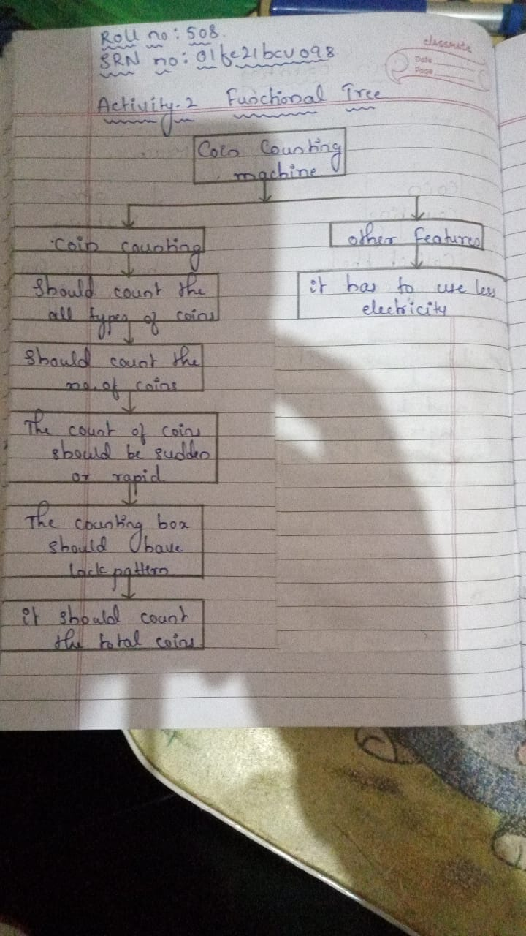

**ACTIVITY 3: - MORPHOLOGICAL CHART.**

|  |  |  |  |  |  |
| --- | --- | --- | --- | --- | --- |
| Sl.NO | SUB-FUNCTIONS | MEANS 1 | MEANS 2 | MEANS 3 | MEANS 4 |
| 1. | Count the number of coins. | LASER SENSOR | ULTRASOUND SENSOR | PHOTO-ELETRIC SENSOR | MAGNETIC SENSOR |
| 2. | Collecting of coins in collector box. | BOX MADE OF METAL OR ALLOY. | BOX MADE OF THERMOPLASTIC. | BOX MADE OF THERMOSETTING POLYMER. |
| 3. | Indicating the complete fill of collector box. | PHOTO-ELETRIC SENSOR | LASER SENSOR |  |  |
| 4. | Lock to the collector box. | TRADITIONAL LOCK | BIO-METRIC LOCK | PIN CODE LOCK |  |

**ACTIVITY 4:- SELECTION OF MEANS FOR EACH CONCEPT.**

|  |  |  |  |  |  |
| --- | --- | --- | --- | --- | --- |
| Sl.no | SUB-FUNCTIONS | CONCEPT-1 | CONCEPT-2 | CONCEPT-3 | CONCEPT-4 |
| 1. | Counting no.of coins. | Laser senor | Ultrasound  Sensor | Photoelectric sensor | Magnetic sensor |
| 2. | Collector box. | Metal box | Thermoplastic | Thermosetting polymer | Metal box |
| 3. | Box full indication | Photo electric sensor | Laser sensor | Photoelectric senor | Laser senor |
| 4. | Lock to the box | Traditional  Lock | Biometric lock | Pincode lock | Traditional lock |

|  |  |  |  |
| --- | --- | --- | --- |
| SL.NO | SUB-FUNCTIONS | CONCEPT-5 | CONCEPT-6 |
| 1. | Counting no.of coins. | Laser senor | Ultrasound  Sensor |
| 2. | Collector box. | Thermoplastic | Thermosetting polymer |
| 3. | Box full indication | Laser sensor | Photoelectric senor |
| 4. | Lock to the box | Biometric lock | Pincode lock |